Sangala Studio User Guide
Sangala Studio is a Digital Fabrication Tool developed to support the course, Introduction to Design through Making. The word "sangala" means joy in the Lugisu language spoken in the Mt. Elgon region in East Africa. A version of this course focused on exploring art and engineering is being developed to support a collaboration with East Africa. A book, Design through Making: Art and Engineering, has also been developed to support this special version of the course. It focuses on a sequence of activities that move from two-dimensional art to three-dimensional design and then incorporate animated and automated mechanisms.
These activities have been developed over sixteen years. They began in 2010 with the construction of the Laboratory School for Advanced Manufacturing, a joint project of the Charlottesville City School System and the University of Virginia, led by the faculty and staff of the Make to Learn Laboratory. They continue to be developed through a collaboration between the University of Virginia and REACH for Uganda, anchored by EDIS 3050 at the University of Virginia and a pilot course at Hawthorne-Scribner High School.
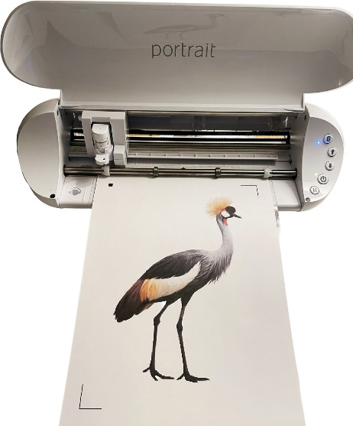
Figure 1. Using Sangala Studio and a Silhouette die cutter to cut out the silhouette of a crested crane.
The Sangala Studio digital fabrication tool supports the design activities in the 2D design portion of the course covered in Chapters 1 through 3 of the accompanying book. These activities include development of a collage that is used as scaffolding to create a shadowbox. A shape designed in Sangala Studio is fabricated on a digital die cutter. This guide covers the 2D features needed for these projects: importing and tracing a photo, drawing and combining shapes, and doing a print-and-cut. The final section introduces the three-dimensional design mode, which is used later in the course for objects made on a 3D printer.

1. Workflow for Creating a Collage
To make a collage, the workflow follows this sequence using Sangala Studio:
- Identify an image.
- Import the image into Sangala Studio.
- Remove the background.
- Use the outline of the image as the template for an object in the collage.
- Send the outline to the digital die cutter to cut out the shape from cardstock.
The pieces can be cut one at a time from colored cardstock, as in step 5 above. They can also be finished together: give each piece a paper color, arrange them on the page, and print the whole collage in color on a single sheet of white cardstock. The die cutter then cuts every piece out in one pass (Section 11).
The following sections describe the tools in Sangala Studio used to fabricate the collage.

2. Getting started
Sangala Studio runs in a web browser and controls the die cutter — the machine that cuts a shape by tracing its outline with a small blade. The window has three parts:
- The mat in the center of the Sangala Studio workspace is the large white rectangle. It represents the sticky carrier sheet — the physical sheet that holds the paper flat and carries it through the die cutter. Cardstock or paper placed on the mat is what the machine will cut.
- The Tools Palette runs down the left edge. Each button is one tool for drawing or editing shapes.
- The Fabricate Panel on the right holds the green Make It! button, short status messages, and — whenever a shape is selected — a panel for changing that shape.
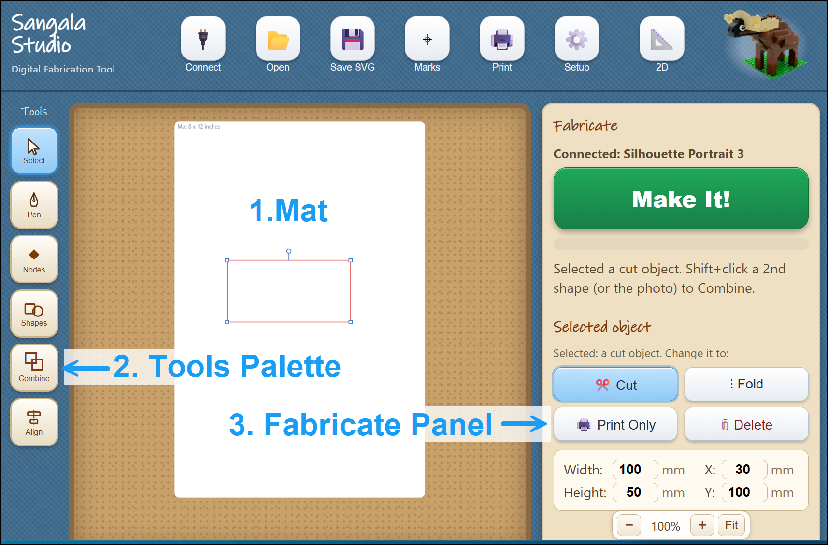
Figure 2. The Sangala Studio window, with the Mat (1) labeled in the center,
the Tools Palette (2) on the left, and the Fabricate Panel (3) on the right.
To use the die cutter, first connect to it:
- Plug the die cutter into the computer with its USB cable and turn it on.
- Click the Connect icon at the top left.
- When the status in the Fabricate Panel changes from "Not connected" to the machine's name (Silhouette Portrait 3 in this instance), Sangala Studio is ready to fabricate shapes.
A design can be made at any time; a connection to the die cutter is only needed to cut out a shape.

3. Cut lines and fold lines
The die cutter treats a line in one of two ways, and it cannot tell them apart on its own, so each line must be marked. There are three kinds:
- Cut Lines — the blade cuts all the way through the cardstock. A cut line is a solid red line.
- Fold Lines — The die cutter makes a series of dashed cuts to create a crease (fold line) so that the cardstock folds cleanly along it. A fold line is a dashed blue line.
- Print Only — Shapes and images can be printed on an inkjet printer. This is used for artwork or shapes.
In the illustration below (Figure 3), a calibration card developed as a test file is shown with a cut line (a solid red line) around the perimeter of the card and a fold line (shown as a dashed blue line) in the center of the card.
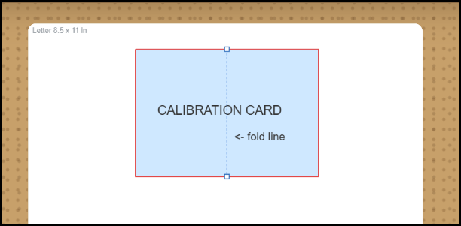
Figure 3. A cut line is shown in red while a fold line (in the center) is a dashed blue line.
The die cutting machine will create dashed scores in the center of the card so that it can be folded and will cut out the card from the cardstock using the solid red line as a guide that determines the path of the cutting blade.

4. Importing and tracing a photo
Sangala Studio can turn a photograph into a silhouette — the solid outline of a subject with all its inner detail removed, such as the shape of a crowned crane standing black against the page.
- Click Open (the Folder Icon) and choose a photograph (a .png or .jpg file). It appears on the mat as a reference layer.
- Click Remove BG (the Wand Icon). Sangala Studio attempts to find the main subject in the foreground. It then draws a red line around the outline of the object. This outline is the path that the blade will follow to cut out the silhouette of the object.
- Use the two sliders that appear in the Fabricate Panel to make adjustments:
  - Silhouette Threshold makes the outline tighter or looser.
  - Ignore Specks removes small stray bits so that only the main subject is outlined.
- Click Confirm. Sangala Studio removes the background outside of the red cut line, leaving the subject and the red path the blade will follow around it.
- There are two options at this point:
    - To simply create a silhouette of the object from colored cardstock,
      - Place the cardstock on the carrier sheet and load it into the die cutter.
      - Then click the Make It! button on the Fabricate Panel to cut out the silhouette.
    - To print the image and cut it out of the printed card stock:
      - First turn registration Marks on. Three marks appear on the page; the die cutter reads them to line the blade up with the printed picture.
      - Then click Print to send the image (with registration marks) to print the picture on an inkjet printer.
      - Next place the printed cardstock on the carrier sheet and load it into the die cutter.
      - Finally, click the Make It! button on the Fabricate Panel to cut out the image.
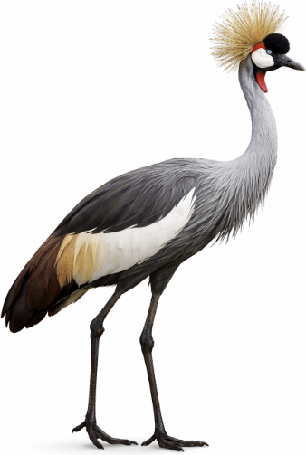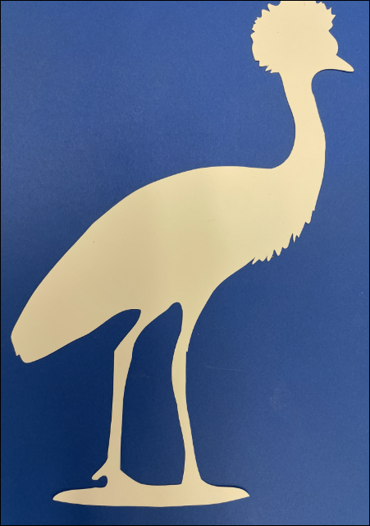
Figure 4. A photograph of a crane (left) and its silhouette cut out of cardstock (right).

5. Drawing shapes
Not every shape comes from a photo. Two tools draw shapes directly.
The Shapes tool (the rectangle-and-circle icon) opens a small menu:
- Click Shapes, then choose Line, Rectangle, or Circle.
- Drag the cursor across the mat. A rectangle grows from corner to corner; a circle grows from its center outward.
A line runs straight from where the drag starts to where it ends. Hold Shift to keep it level, upright, or at 45 degrees. A line is a Cut line at first — it slits the paper; click Fold to make it a crease instead.
- Release the mouse button to create a shape.
Note: To set an exact size, select the shape and type its measurements in the Selected Object panel (Section 6).
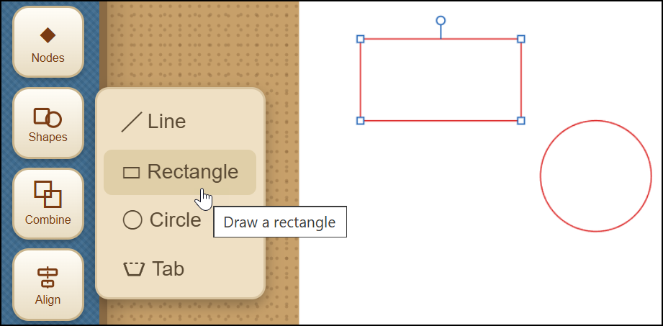
Figure 5. The Shapes menu (Line, Rectangle, Circle, Tab) and shapes drawn on the Mat workspace.
The Tab tool (also in the Shapes menu) adds a glue tab — the small flap that folds back and is glued when a flat design is assembled into a box or model:
- Click Shapes, then choose Tab.
- Press on the edge of a shape and drag along it. The stretch covered becomes the fold hinge, and a preview of the tab follows the drag.
- Release, and the tab is built: three cut sides, a fold hinge on the edge — and the shape's own edge beneath the hinge is removed automatically, so the tab stays attached instead of being cut off.
The tab's size is chosen automatically from the length of the hinge. Its pieces are grouped so the tab moves as one; use Ungroup to adjust a side by hand.
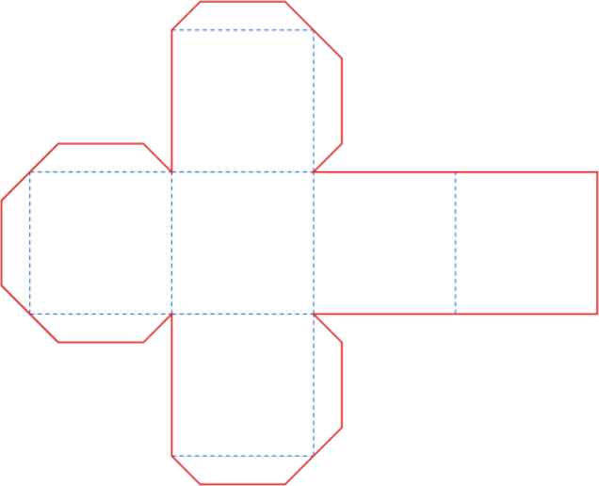
Figure 6. A box with cut lines, fold lines, and glue tabs.
The Pen tool (the pen-nib icon) draws a free-form outline point by point — useful for a custom shape such as a mountain profile:
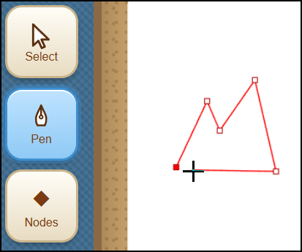
Figure 7. The Pen tool (used to draw a mountain profile in this example).
- Select the Pen icon in the Tools menu.
- Click on the mat to place each corner point. A red line follows the cursor to preview the next segment.
- To close the shape, click the first point again or press Enter.
If a point lands in the wrong place, Ctrl-Z takes it back — one point at a time — and Ctrl-Y puts it back. Pressing Esc, or choosing another tool, leaves the Pen and keeps the outline as it stands: an unfinished outline stays on the mat as an open line rather than being discarded, so nothing is lost by stepping away in the middle of one. Ctrl-Z removes the outline if it is not wanted after all.
The Pen can also carry on from an outline that is already on the mat. Wherever an outline has a loose end — after Break at Node, for example — the end fills in as the Pen approaches it. Click the end and the Pen continues from there; click the outline's other end to close the shape, or press Enter to leave it open. This is how a traced silhouette is opened, extended, and closed again to make a region that can be given a paper color, such as the foliage of a tree.

6. Editing shapes
Selecting a shape with the Select tool (the arrow) opens the Selected object panel on the right, which is where a shape is measured and changed. A shape that has been given a paper color can be selected by clicking anywhere inside it; a shape that is only an outline is selected by clicking on the outline itself.
- Move or resize — drag the middle of a shape to move it; drag a corner handle to resize it.
- Nudge — with a shape selected, the arrow keys move it 0.1 mm at a time; hold Shift for 1 mm steps — a precise final adjustment after a shape has been dragged close with the mouse.
- Rotate — drag the round handle that appears above a selected shape; hold Shift to snap to fifteen-degree steps. Rotating a rectangle converts it into an editable outline. The same handle appears above a Tab, a Group, or several shapes selected together, and turns all of them as one around their shared center.
- Set the line type — click Cut, Fold, or Print Only to set the line type that determines what the die cutter does with that shape (Section 3 above). The highlighted button is the current setting.
- Paper color — give a shape the color of the card it will be cut from, so the mat shows the finished collage instead of a tangle of outlines. Choose one of the colors in the Selected object panel, or the color wheel at the end of the row for any other. The color is never cut, so the die cutter still follows the outline. It does now print, though: with registration Marks on, every colored piece prints in its color on one sheet, ready to cut out together (Section 11).
- Layer — where shapes overlap, the one drawn most recently sits in front. Back, Lower, Raise and Front change that order, so the sky can be moved behind the grass. On the keyboard, Page Down and Page Up move a shape one step, and End and Home send it to the back or bring it to the front.
- Exact size and position — the panel shows the measurements in a small box; click a number and type to set an exact value.
- Simplify the outline — an outline is made of nodes (the points where the line changes direction). Fewer nodes cut more smoothly. Simplify nodes reduces the count while keeping the shape; the Nodes tool (the diamond icon) lets individual points be dragged, added, or deleted.
- Delete — click the Delete button, or press the Delete key on the computer keyboard.
- Undo and redo — Ctrl-Z undoes the last change; Ctrl-Y (or Ctrl-Shift-Z) redoes it.
- Duplicate — Ctrl-C copies the selected shape and Ctrl-V pastes a copy beside it, complete with its line type and settings. Paste again for more copies.
- Break at a node — with the Nodes tool, click a node and press Break at Node. A closed shape opens there; an open line splits into two pieces. Each piece can then be Cut, Fold, or deleted on its own — three sides Cut and one side Fold makes a glue tab by hand.
- Snap to Fit — when a shape is dragged near another, their corners pull together and lock exactly; a green dot marks the shared point. The magnet button beside the zoom controls turns this off, and holding Alt while dragging moves a shape freely.
To work on several shapes at once, drag a box around them . They can then be moved, deleted, or changed to Cut, Fold, or Print together. Each selected shape is marked by a faint gray panel behind it.
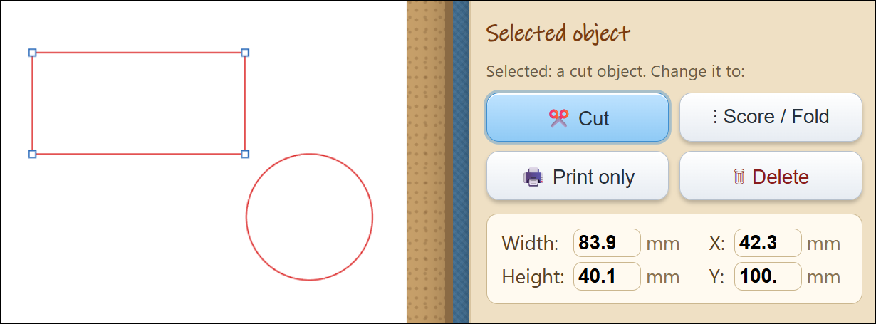
Figure 8. The Selected Object panel that is used to set the line type (Cut, Fold, Print)
and enter exact specifications for the size and position of the shape.

7. Drawing with Snap!
Snap! is a block programming language in which a turtle draws by moving across the screen — the turtle graphics that have been used in classrooms for many years. Sangala Studio can take what the turtle drew and cut it, crease it, or draw it on paper. A Snap! program therefore becomes a design, and an existing turtle program becomes one simply by choosing the color of its pen.
1. Open Snap! — select the Snap! icon in the Tools palette. Snap! opens in a window of its own. Start it Snap! using this button: a drawing can only be imported to Sangala Studio through a Snap! window that Sangala Studio itself has opened.
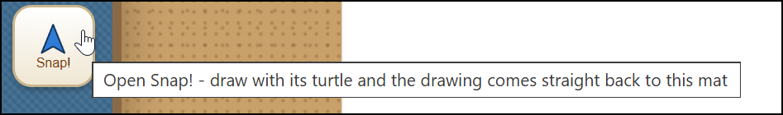
Figure 9. The Snap! button in the Tools Palette
opens Snap! in a separate window.
2. Add the Sangala blocks (first time only) — in Snap!, choose File, then Import, and select the file Sangala for Snap.xml. Two blocks appear in a Sangala palette. In Snap!'s settings menu (the gear), tick JavaScript extensions.
3. Build the script — put log pen vectors for Sangala at the top of the drawing script, above pen down, and send pen trails to Sangala at the bottom, below pen up.
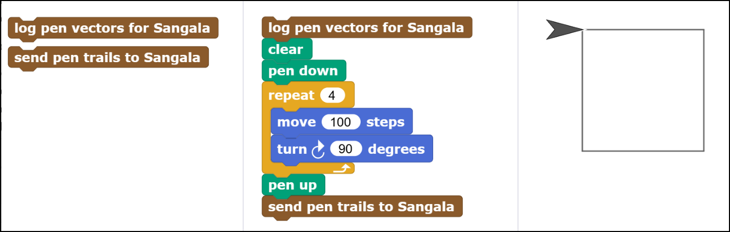
Figure 10. The two Sangala blocks in Snap! (left), a script that draws a square
(center), and the square the turtle has drawn on the Snap! stage (right).
4. Choose what the machine will do — the pen color is the instruction. A blue line becomes a fold line; a line of any other color becomes a cut line, or a drawn line if there is a pen in the tool holder instead of a blade.
5. Send the drawing — click the script. The drawing appears in the middle of the mat, where it can be moved, reshaped with the Nodes tool, or combined with other shapes like any other design.
To draw rather than cut, put a pen in the tool holder, choose Pen as the material in Setup, and press Make It! The die cutter draws the turtle's path at full size on paper. To cut the design out instead, put the blade back in and choose the material being cut. A drawing that mixes red and blue lines becomes a paper-craft net, in which the red lines are cut and the blue lines are creased ready to be folded.
One hundred turtle steps arrive as about 26 mm, so a drawing that fills Snap!'s stage is roughly the width of a sheet of paper. A design too large for the page can be reduced with Scale in the Setup panel.
Sangala Studio can also send a design the other way — onto the Snap! stage, where a Snap! program can use it as the costume for a sprite. This is a way to make artwork for a program, such as the dials and buttons of a dashboard, by drawing it rather than writing code for it.
1. Choose the design — draw or select the shapes in Sangala Studio. If nothing is selected, the whole mat is sent.
2. Bring it across — in Snap!, click get design from Sangala. The design appears on the Snap! stage as a black outline. (Snap! must have been opened from the Snap! icon, as above, so that the two windows can talk.)
3. Make it a costume — hold the Shift key and right-click the stage, then choose pen trails from the menu. A new costume appears in the sprite's costume library.
4. Add color — open the costume in Snap!'s paint editor and fill the enclosed areas with color.
The design crosses in black and white; color is added in Snap!. The outline itself stays in Sangala Studio, so the same design can also be cut or folded.

8. Combining shapes
The Combine tool (the overlapping-squares icon) joins two shapes. Select one shape, then hold down the Shift key and select a second shape (which will then be highlighted in orange). Then choose:
- Union — join both shapes into one outline.
- Difference — remove the second (orange) shape from the first.
- Intersect — keep only the part where the two shapes overlap.
To place a photo inside a circle (or any outline) for a collage: open the photo, draw a shape over the part to keep, click the shape, then hold Shift and click the photo, and choose Intersect. Everything outside the shape is removed, leaving a print-and-cut of the cropped photo.
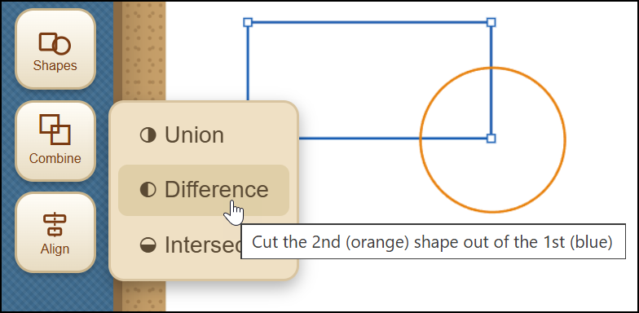
Figure 11. Using the Combine option to combine two overlapping shapes.

9. Aligning shapes
The Align tool (the centered-bars icon) lines shapes up. Select two or more shapes — draw a box around them, or click one and Shift-click another — then choose:
- Vertical — the shapes line up vertically.
- Horizontal — the shapes line up horizontally.
- Center — the shapes are centered on one another.
The largest shape stays in place and the others move to it, so Center drops a small circle exactly into the middle of a square frame.
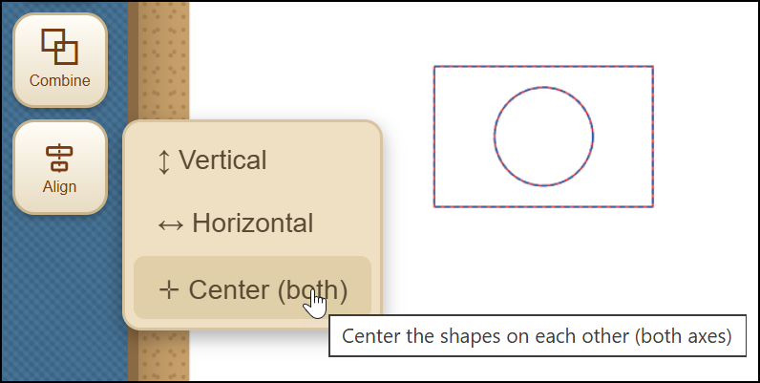
Figure 12. Using the Align option to center two shapes.

10. Examining Fine Detail
To inspect fine detail:
- Zoom with the mouse wheel, or the plus and minus buttons at the bottom of the Fabricate Panel.
- Fit returns to the whole page.
- Pan (when zoomed in) by holding the Space bar and dragging.
Zooming changes only the view, not the real size of the design.

11. Cutting Out a Design
- Open Setup (the gear icon) and choose the Material (Paper, Cardstock, Heavy Cardstock, Vinyl, or Pen). This is used to adjust Force, Speed, Blade, and the number of Passes; thicker material needs more force and more passes. Set the Position if the design should sit at a particular spot on the mat, then close Setup.
- Place the cardstock or other material on the carrier sheet and load it into the die cutter.
- Decide whether to print first:
  - For a plain silhouette cut from colored cardstock, leave registration Marks off and press Make It! The blade cuts the outline directly.
  - For a print-and-cut (a full-color picture, or a collage of colored pieces, printed and then cut out):
- Turn registration Marks on,
- Select Print to print the artwork with three registration marks (small targets the die cutter reads to line itself up),
- Load the carrier sheet into the die cutter,
- Then select Make It!
A sensor in the tool head of the die cutter will use the registration marks printed on the page to locate the position of the artwork and cut exactly around the areas designated by cut lines.
A collage made from colored pieces is cut this way in a single pass. Give each piece a paper color, arrange them on the page, and Print: every piece prints in its color on one sheet of white cardstock. Make It! then cuts every outline at once, so the pieces need not be cut one color at a time. Because the color is printed rather than cut from colored card, the cut edge shows the white core of the sheet.
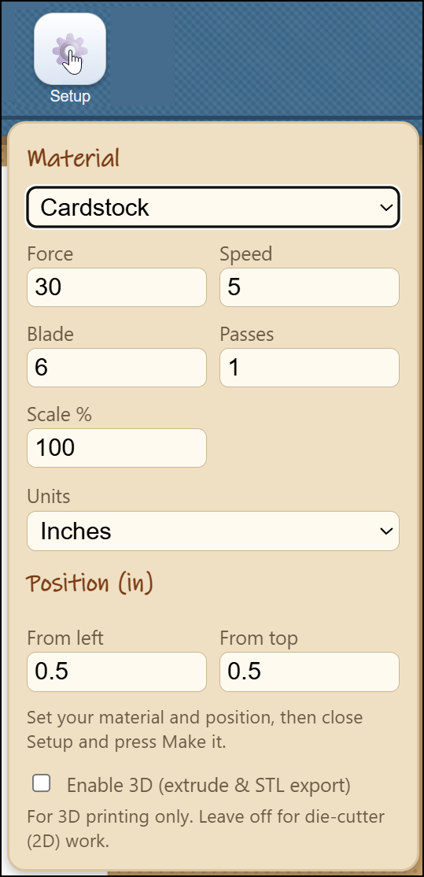
Figure 13. The Setup menu can be used to adjust the material settings.
12. Saving the Design
Save SVG (the disk icon) writes the design to a file that can be reopened later or shared.
- A photo opened only as a reference for tracing is not saved.
- Once the background of a shape has been removed to create a silhouette outline (or it has been cropped to a shape), the picture becomes part of the print-and-cut design. The image is then printed and saved with the design so that it reappears when the file is reopened.

13. Designing in 3D
Sangala Studio also has a three-dimensional mode for objects made on a 3D printer rather than the die cutter. Where the die cutter cuts a flat outline from cardstock, a 3D printer builds a solid object in layers of plastic. In 3D mode a design is saved as an STL file — the standard file a 3D printer reads — rather than sent to the die cutter as a cut.
Switching to 3D. The button at the top right, next to the logo, switches between 2D and 3D. It reads 2D for die-cutter work; pressing it changes the label to 3D and reveals three controls that stay hidden in 2D: the Brick tool in the Tools Palette, and the 3D View and Export STL buttons near the top. Because a 3D design is printed rather than cut, the die-cutter connection message is not shown in 3D mode.
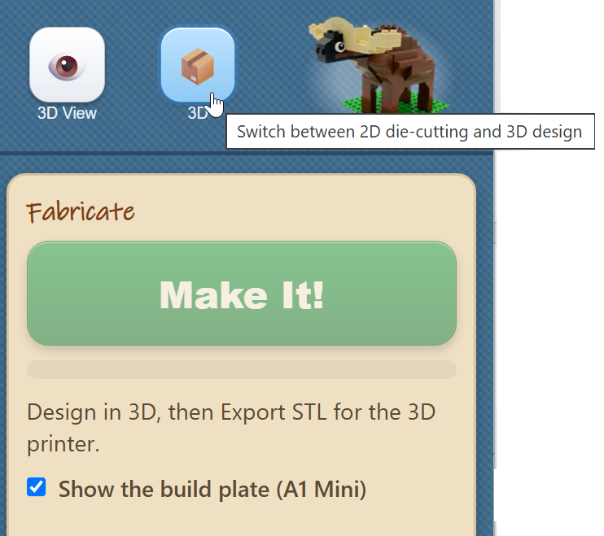
Figure 14. The 2D/3D toggle and the 3D View button at the top right;
in 3D mode the Fabricate Panel prompts to Export STL for the 3D printer.
Giving a shape depth. A flat shape becomes a solid when it is given a height. Any drawn shape can be raised — a rectangle, a circle, or a free-form outline drawn with the Pen — so that a triangle becomes a wedge and a four-sided outline becomes a sloped block, the shapes from which angled parts are built. Once a shape is selected, the Selected-object panel shows two further measurements:
1. Depth — how tall the object stands, the distance the flat shape is raised to form a solid.
2. Base — how far the object sits above the printer bed. A Base of zero rests the object on the bed; a larger Base lifts it, which is useful when one part is meant to rest on top of another.

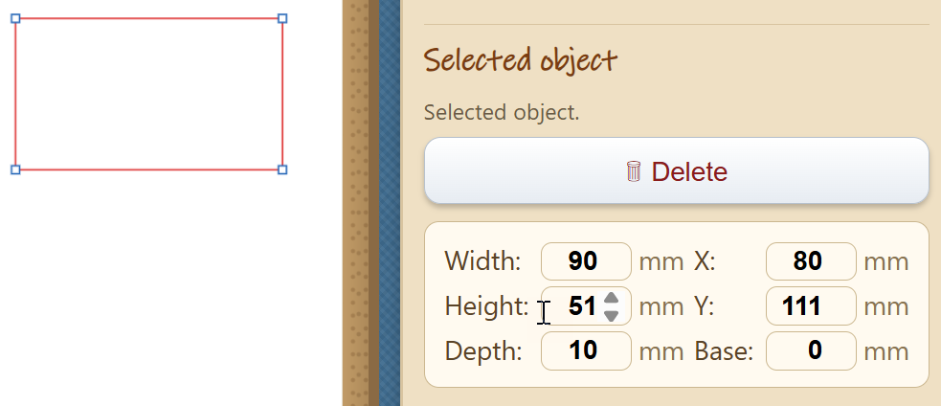
Figure 15. A rectangle selected in 3D mode. The Selected-object panel
adds Depth and Base, which raise the flat shape into a solid.
The Brick tool. The Brick tool places a construction brick with studs on top. Once a brick is selected, the Brick size panel adjusts it:
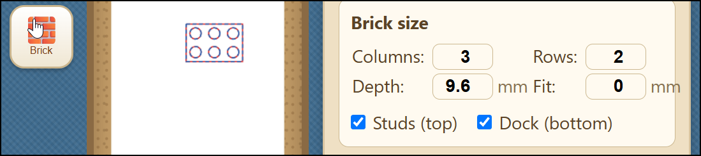
Figure 16. The Brick tool and its Brick size panel: Columns, Rows,
Depth, and Fit, with Studs (top) and Sockets (bottom) checkboxes.
1. Columns and Rows set how many studs the brick has across and deep. A brick of one column and one row, given a large Depth, becomes a tall, narrow post — for example, a leg.
2. Depth sets the brick's height.
3. Fit adjusts how tightly two printed bricks snap together. Zero is the standard LEGO size. A minus value tightens the grip by making the studs slightly fatter; a plus value loosens it. Printers differ, so if new bricks feel loose, try -0.2 first and adjust in small steps.
4. Studs (top), turned off, leaves the top smooth — suited to a surface such as a wing that should carry no studs.
5. Sockets (bottom), turned off, closes the underside with a flat base — suited to a part that is glued to a surface rather than pressed onto studs.
Previewing in 3D. The 3D View button shows the object as a rotatable model. Dragging rotates the model and the scroll wheel zooms, so the model can be turned to inspect its underside. The Show the build plate checkbox, which begins unchecked, adds the Bambu A1 Mini bed beneath the object; the object then appears at true size against the printer, and the Base value reads as the gap between the object and the bed. Pressing 3D View again returns to editing.
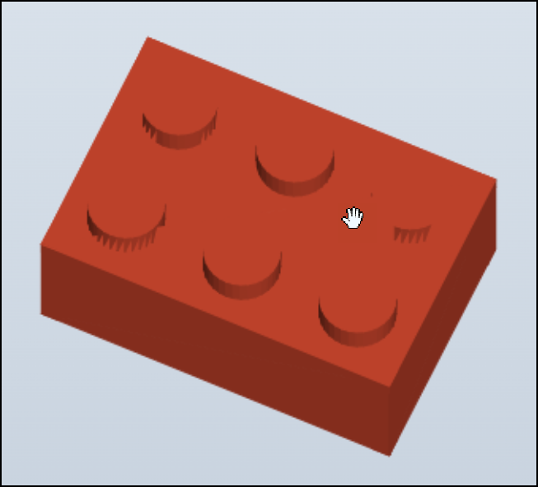
Figure 17. The 3D View shows the finished object as a rotatable
model; dragging rotates it and the scroll wheel zooms.
Saving for the printer. The Export STL button saves the design as an STL file, which is then opened in the printer's own software (Bambu Studio) to print the object.
14. Quick Reference

Tool | Action
Move or resize a shape | Select, then drag the shape or a corner
Draw a rectangle or circle | Shapes, Rectangle or Circle, then drag
Draw a free-form outline | Pen, click each point, Enter to finish
Carry on from a loose end | Pen, click the end of the outline
Reshape an outline | Nodes, then drag, add, or delete points
Make a line fold instead of cut | Select it, click Fold
Join, subtract, or overlap two shapes | Combine, Union, Difference, or Intersect
Center one shape in another | Select both, Align, Center
Cut a subject out of a photo | Open the photo, Remove BG, Confirm
Crop a photo to a circle or shape | Draw the shape, then Combine, Intersect
Print, then cut on the print | Marks on, Print, Make It!
Rotate a shape | Select it, then drag the round handle above it
Nudge a shape a small distance | Select it, then press an arrow key (Shift for 1 mm)
Fill a shape with a paper color | Select it, then click a color in the Selected object panel
Change which shape is in front | Select it, then Back, Lower, Raise or Front
Undo or redo a change | Ctrl-Z undoes; Ctrl-Y redoes
Draw with Snap!'s turtle | Snap!, run the script, then send pen trails to Sangala
Draw a straight line | Shapes, Line, then drag; Fold makes it a crease
Add a glue tab to a shape | Shapes, Tab, then drag along the shape's edge
Break a shape apart at a node | Nodes, click a node, Break at Node
Duplicate a shape | Ctrl-C copies; Ctrl-V pastes a copy
Turn Snap to Fit on or off | The magnet button beside the zoom controls

15. Tool Sequences for Specific Designs
- A Single Silhouette — Open a photo, Remove BG, Confirm, then cut. Tidy the outline with Simplify nodes or the Node editing tool.
- A Collage — Draw or trace each shape, use the Shapes and Pen tools, and Align to position them. Cut each shape separately on a different color of cardstock (for simple silhouettes) and place the cut-out shapes by hand to form a collage.
- A Shadowbox Frame — Draw a square and a circle with Shapes, use Align Center to place the window, add folding tabs, and set the fold lines to Fold so the die cutter cuts them as a dashed fold line instead of cutting all the way through.

